|  |  |  |  |  |
| --- | --- | --- | --- | --- |
| Arctic Do you want an adventure of a lifetime? then come visit the Arctic there’s loads to see and do which will make this an unforgettable trip. Arctic animals You could be lucky enough to see some of these truly breathtaking animals such as:  Polar bears=one of the strongest of the Arctic animals.  Harp seals=They can dive upto 60 metres deep and stay under water for 15 mins.  Humpback whales=One of the largest aquatic mammals in the world.  Arctic fox=They keep a partner for life and are nocturnal.  Walrus=They have large tusks which can grow upto 1 metre in length.  Places of interest to visit and fun activities  Toonik tyme is a spring celebration of the longer days and return of the migrating animals you can join in with family friendly games, craft workshops ,dog sleigh rides and also snow mobile races.  Boat tours where you can see the icebergs up close and whale watching.  Hiking, climbing and camping at the Auyuittuq national park.  Ice fishing and also rides on snow mobiles.  Bird cliffs at Sirmilik national park home to a migrating bird sanctuary watch the birds returning home to the Arctic.  If you visit in springtime there is the chance to maybe get a glimpse of the polar bear cubs.  Looking for a holiday to get away from the hustle and bustle of everyday life then the Arctic is the place to be there is now approximately 4 million people living here permanently in the whole of the Arctic of them the indigenous population range from 80% in Greenland, 50% Canada,20%Alaska,15% in Northern Norway and as little as 3-4% in Northern Russia.  Depending on what time of year you go and the latitude at which you are situated the hours of daylight varies areas above the artic circle have 24 hours of sunlight each summer and 24 hours of darkness each winter. | [This Photo](https://exceptionalanimals.wordpress.com/2011/03/20/polar-bear-ursus-maritimus/) by Unknown Author is licensed under [CC BY-SA](https://creativecommons.org/licenses/by-sa/3.0/) | Walrus  Try your hand at ice fishing  Perfect for any thrill seeker |  | The enchanting polar bears  The majestic Arctic fox |
|  |  |  |
|  | | |
| Organization Name/Logo |

There are many countries you could visit in the Arctic circle whilst you were here like Northern Russia, Canada, Greenland, Denmark, Alaska, Norway, Sweden and Finland and were sure that if you visited us you would make memories that would last you a lifetime.

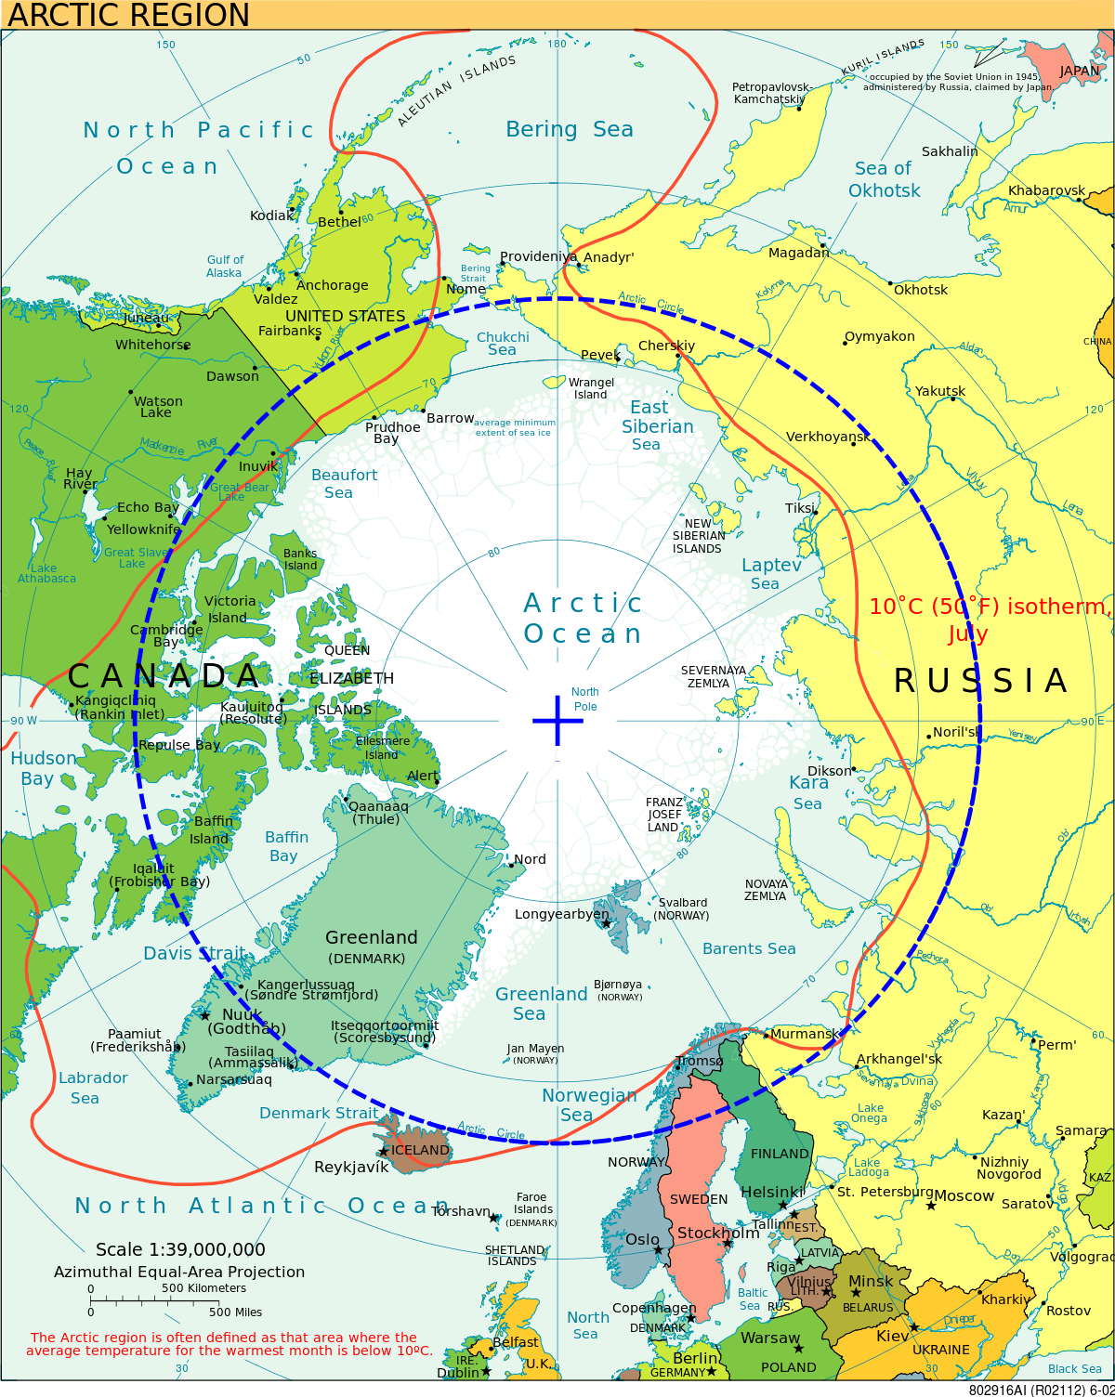

Countries to visit in the Arctic circle.

So if your wanting a fun packed holiday with unforgettable once in a lifetime sights and breathtaking scenery then the Arctic has everything you could possibly want!!!, We look forward to seeing you soon.

|  |  |  |  |  |
| --- | --- | --- | --- | --- |
|  |  | **Title or Heading Here** In the same way you change the colors, you can update the fonts of the entire document easily! From the Design tab, choose a font combination that fits your taste.  Reset the theme to restore the template to its original state! **Customize Heading/Text** To change any of the text in this document, just click on the block of text you want to update! The formatting has already been programmed for ease of formatting. |  | “Large quote goes here.” |
|  |  |
| **Title or Heading Here** You can easily change the overall colors of the template with just a few clicks. Go to the Design tab and click on Colors. From the list of colors, you can choose a different color scheme. As you hover over the different choices, you can see what the overall feel of the document will change with each different option.  Changed the color and want to go back to the original design? Easy! Just go back to the Design tab and choose the Themes option. From the list, click the option to reset the theme of this template. And just like that, your document color scheme will be restored to its original! | **Title or Heading Here** In this panel, you can highlight even more information about your organization! Tell the audience why you are the best! Don’t be shy! Share, explain, and tell us what makes your company so great!  Plenty of text will fit in any of these panels. Simply click on the placeholders and add your own text. **Title or Heading Here** We think the design of this brochure is great as is! But, if you do not agree, you are able to make it yours by making a few minor design tweaks! Tips on updating specific features are available throughout this example text. |
|  |
|  |